RECOMMENDATIONS (STUDENT)

- Click on the ASSIGNMENTS tab of the main menu.
- At the bottom of the screen, click on the button that says "Request a Recommendation."

- After clicking on the button, a dialog box will appear. Next to the label Teacher: you will see a drop-down with a list of teachers.
- If you are in 9th, 10th or 11th grades, choose 2 academic teachers (NOT Advisors) you have during the current school year (ex. Juniors choose 2 teachers they have during their Junior year).
If you are in 12th grade, this list will contain all the teachers and administrators in the school. Seniors choose 2 people from the following list: Administrators, Guidance Counselors, LHS Staff, LHS Coaches, or Club/Activity Advisors
- Each teacher can only give you one Social Expectations recommendation during your high school year; this means the list will not include any teachers who has previously completed a recommendation for you.
- After you have selected the teacher, click on "Send Request." ONLY SEND 2 REQUESTS.
Your teacher will receive a message that you have submitted a request for a recommendation.

After the teacher has completed the recommendation, you can see the response:
- Click on ENTRIES on the main menu
- Click on the RECOMMENDATIONS tab
- You can see the recommendation by clicking on "View Assessment."
- Click on the ASSIGNMENTS tab of the main menu.
- Find the Class labeled PORTFOLIO
- Find the REFLECTION assignment in the PORTFOLIO Class
- Click on the +ADD button
- Click on the EDIT button of the REFLECTION assignment
- Read the REFLECTION PROMPT

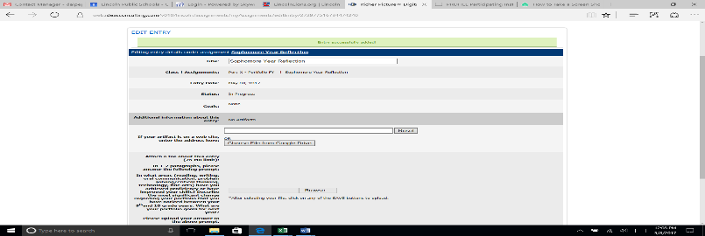

- On a new screen, OPEN a new document on your GOOGLE DRIVE
- Write your Reflection response on the Google Doc and SAVE to your GOOGLE Drive
- GO BACK to RICHER PICTURE (FOLLOW STEPS 1-4 if you logged off your page)
- Click on the CHOOSE FILE FROM GOOGLE DRIVE button
- Choose the REFLECTION file on your Google Drive
- Click on the ALLOW RICHER PICTURE ACCESS TO THIS FILE button
- Click on the SAVE STAY ON THIS PAGE button. YOU MUST DO STEP 11 BEFORE STEP 12.
